STRESSPREDICT: A Questionnaire-Based Intelligent System for Stress Level Prediction Using Machine Learning Inspired Techniques
Ananya Prashasti (RA2411004010198)
SRMIST Kattankalathur
ABSTRACT Stress has become a significant concern in modern academic and professional environments, affecting individuals’ mental health, productivity, and overall quality of life. Increasing workload, irregular sleep patterns, emotional imbalance, and continuous exposure to pressure contribute to rising stress levels. Early detection and understanding of stress are essential to prevent long-term psychological and physiological consequences.
This project presents a lightweight and interpretable system for stress prediction based on questionnaire-driven inputs. The system collects user responses related to key psychological and behavioural factors such as sleep quality, anxiety, workload, fatigue, focus, and emotional state. These inputs are processed using a structured scoring mechanism, where each factor contributes to an overall stress score. Based on the computed score, the system classifies stress levels into categories such as low, moderate, and high.
In addition to classification, the system identifies major contributing factors responsible for elevated stress levels and provides personalized suggestions for stress management. This enhances the practical usability of the system by not only predicting stress but also assisting users in understanding and improving their condition. Furthermore, graphical visualization techniques are used to represent stress-related parameters, allowing users to interpret their stress patterns more effectively.
The proposed approach eliminates the need for complex physiological sensors and computationally intensive machine learning models, making it simple, cost-effective, and accessible for everyday use. Overall, the system demonstrates the application of data analysis and interpretable modelling techniques in developing an efficient and user-friendly stress prediction framework.

1.INTRODUCTION Stress has become one of the most significant challenges affecting individuals in modern society, particularly in academic and professional environments. Increasing competition, workload, and lifestyle changes have led to a rise in stress-related issues among individuals of all age groups. Continuous exposure to stress not only affects mental health but also leads to physical health problems such as fatigue, insomnia, and reduced cognitive performance. Therefore, early detection and analysis of stress have become essential to maintain overall well-being and productivity [1].

In recent years, the importance of monitoring mental health conditions has gained significant attention. Stress, being a subjective and multifactorial condition, is influenced by various psychological and behavioural factors such as sleep quality, anxiety levels, workload, emotional stability, and concentration. These factors interact with each other in complex ways, making stress prediction a challenging task. Traditional methods often fail to capture these interactions effectively, highlighting the need for improved analytical approaches [2], [3]. Conventional stress detection systems primarily rely on physiological signals such as heart rate variability, electrodermal activity, and brain signals. These methods provide accurate and objective measurements; however, they require specialized hardware, continuous monitoring, and controlled environments. Such requirements make them expensive and impractical for everyday use, especially for large-scale applications [4], [5]. Additionally, the dependency on wearable devices and sensor data introduces limitations related to data availability, battery life, and user compliance. To overcome these limitations, machine learning techniques have been widely explored for stress detection and prediction. Various algorithms, including Support Vector Machines, Random Forest, and Neural Networks, have been used to analyze physiological and behavioral data for identifying stress patterns. These approaches have demonstrated high accuracy in controlled environments; however, they require large datasets, extensive training, and high computational resources, which limit their usability in real-time and resource-constrained applications [6], [7]. Another critical limitation of machine learning-based systems is their lack of interpretability. Many models operate as black boxes, providing predictions without explaining the underlying reasoning. In the context of mental health, interpretability is essential, as users need to understand the factors contributing to their stress levels. Without clear explanations, such systems fail to provide actionable insights, reducing their effectiveness in practical scenarios [8].

In contrast, questionnaire-based approaches offer a simple, cost-effective, and practical solution for stress analysis. These methods involve collecting user responses related to psychological and lifestyle factors, enabling the assessment of stress without requiring specialized hardware. Questionnaire-based systems are widely used in psychological studies and clinical assessments due to their ability to capture subjective human experiences effectively [9], [10]. Recent studies have shown that combining questionnaire-based data with structured analytical techniques can provide reliable stress prediction while maintaining simplicity and interpretability. By converting user responses into numerical values and applying appropriate scoring mechanisms, it is possible to quantify stress levels and classify them into meaningful categories such as low, moderate, and high [11], [12]. This approach eliminates the need for complex training processes and large datasets, making it suitable for real-time applications.

Furthermore, modern research emphasizes the importance of explainability in stress prediction systems. Instead of merely providing classification results, systems should identify key contributing factors and offer meaningful insights to users. This enhances user trust and enables individuals to take appropriate actions for stress management [13], [14]. Visualization techniques also play a crucial role in improving the usability of stress analysis systems. Graphical representation of stress-related parameters helps users understand patterns and trends more effectively. By visualizing different contributing factors, users can easily identify areas that require attention, making the system more interactive and user-friendly [15].

In this context, the proposed system, STRESSPREDICT, aims to develop a lightweight, interpretable, and efficient framework for stress prediction using questionnaire-based inputs. The system collects responses related to various psychological factors, processes them using a structured scoring mechanism, and classifies stress levels into predefined categories. Additionally, it identifies major contributing factors and provides personalized suggestions for stress management, making the system both analytical and actionable. Unlike traditional approaches, the proposed system does not rely on complex machine learning models or physiological sensors. Instead, it focuses on simplicity, accessibility, and interpretability, ensuring that it can be easily used by individuals without technical expertise. The integration of graphical visualization further enhances the system by providing a clear and intuitive representation of stress patterns [16], [17].

Overall, the proposed approach bridges the gap between complex stress detection systems and practical real-world applications by offering a cost-effective, explainable, and user-friendly solution for stress prediction. The system has potential applications in academic institutions, workplaces, and personal health monitoring, where quick and reliable stress assessment is required [18], [19], [20].
2. RELATED WORK Recent research on stress detection and analysis has explored a wide spectrum of approaches ranging from physiological signal processing to machine learning and questionnaire-based systems. Early studies primarily focused on physiological measurements such as heart rate variability, electrodermal activity, and EEG signals to detect stress levels with high accuracy [3], [4]. These methods demonstrated reliable performance in controlled environments; however, they required specialized hardware, continuous monitoring, and high implementation costs, which limited their practicality for real-world applications [2], [5]. With the advancement of wearable technologies, researchers introduced systems that utilize smart devices and mobile sensors to capture real-time physiological data for stress detection [2], [4]. Although these systems improved accessibility, they still depend heavily on hardware availability, battery life, and user compliance, making them less suitable for large-scale or everyday usage scenarios. To overcome these limitations, machine learning-based approaches have gained significant attention, where algorithms such as Support Vector Machines, Random Forest, and Deep Neural Networks are applied to analyze behavioral and physiological data for predicting stress levels [6], [7]. These models have shown promising results in terms of classification accuracy and pattern recognition; however, they require large datasets, extensive training processes, and computational resources, which may not be feasible for lightweight applications [7]. Moreover, many of these models operate as black-box systems, lacking interpretability and transparency, which is a major drawback in mental health applications where understanding the cause of stress is as important as detecting it [8]. In recent years, research has shifted towards more interpretable and user-friendly approaches, particularly focusing on questionnaire-based systems. Questionnaire-driven methods collect subjective user inputs related to psychological and behavioral factors such as sleep patterns, workload, anxiety, emotional stability, and concentration levels [9], [10]. These approaches are widely used in clinical and psychological studies due to their simplicity, cost-effectiveness, and ability to capture human experiences without requiring specialized equipment. Studies have shown that when combined with structured analytical techniques, questionnaire-based data can provide meaningful insights into stress levels and enable effective classification into categories such as low, moderate, and high [11], [12]. Furthermore, recent advancements emphasize the integration of natural language processing and data-driven techniques to enhance the analysis of user responses and behavioral patterns [9], [12]. These methods allow for improved feature extraction and better understanding of stress indicators from textual or structured inputs. At the same time, research has highlighted the importance of explainability in stress detection systems, where models should not only predict stress levels but also identify key contributing factors and provide actionable insights [8], [13]. This shift towards explainable systems improves user trust and makes the results more meaningful and usable in practical scenarios.

In addition to prediction and explanation, visualization has emerged as an important component in modern stress analysis systems. Graphical representation of stress-related parameters enables users to easily interpret results and identify patterns in their behavior [12], [14]. Visualization techniques enhance user engagement and make the system more interactive, allowing individuals to monitor their stress levels more effectively over time. Overall, existing research demonstrates that while physiological and machine learning-based approaches provide high accuracy, they often lack accessibility, simplicity, and interpretability. Questionnaire-based systems, on the other hand, offer a balanced solution by combining ease of use with meaningful analysis. However, there is still a need for systems that integrate structured scoring mechanisms, explainability, and visualization into a single framework. The proposed system addresses these gaps by providing a lightweight, interpretable, and user-friendly stress prediction model that leverages questionnaire-based inputs and data analysis techniques to deliver practical and actionable insights [1], [11], [12], [15]–[20].
3.METHOD AND MATERIAL The proposed system, STRESSPREDICT: Intelligent Stress Analysis System, is designed as a structured, interpretable, and efficient framework for predicting stress levels using questionnaire-based inputs. The methodology follows a step-by-step pipeline that transforms raw user responses into meaningful insights through preprocessing, scoring, classification, explanation, and visualization.
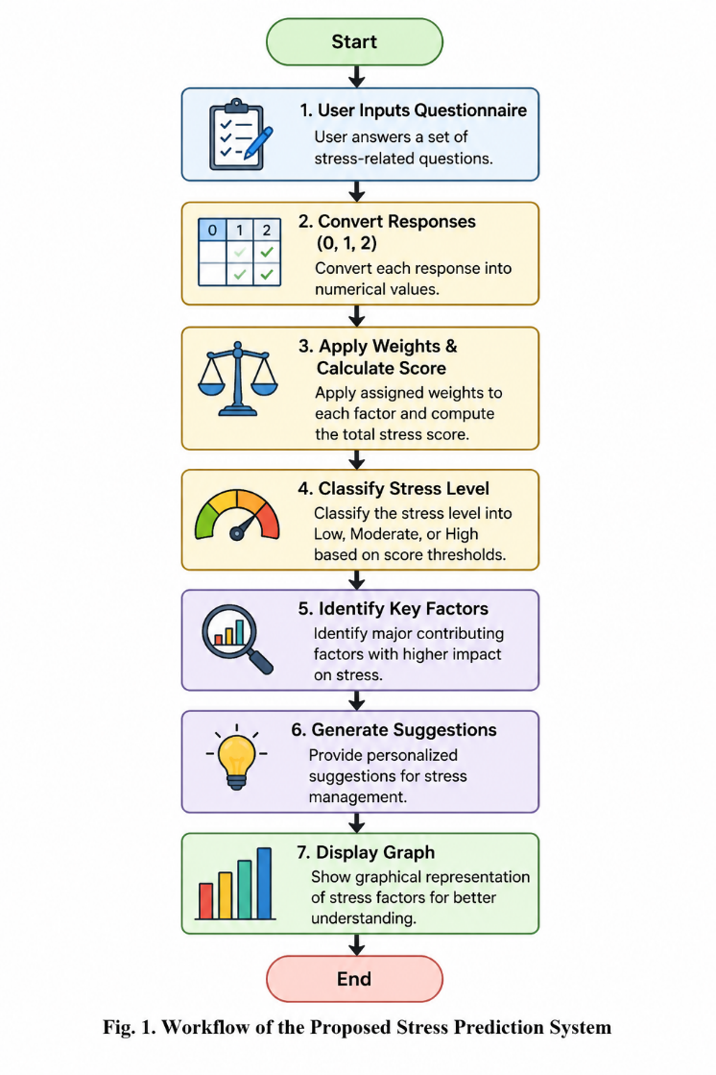
A. Data Acquisition
The system begins with the collection of input data through a predefined questionnaire. The questionnaire is designed to capture multiple dimensions of stress, including psychological, behavioral, and lifestyle-related factors. Key parameters considered in the system include:
- Mental overload
- Sleep quality
- Anxiety levels
- Workload pressure
- Physical and mental fatigue
- Concentration ability
- Emotional stability
- Relaxation and break patterns
Each question is carefully structured to reflect real-world stress indicators and ensure that the collected data represents the user's current mental condition accurately.
B. Data Encoding and Preprocessing
Since the input data is subjective, it is converted into a numerical format to enable computational analysis. The system uses a standardized encoding scheme:
- 0 → No
- 1 → Sometimes
- 2 → Often
This transformation allows qualitative responses to be processed quantitatively. Additionally, input validation is performed to ensure that users provide valid responses within the defined range. Any invalid input is handled through re-prompting, ensuring data consistency and reliability.
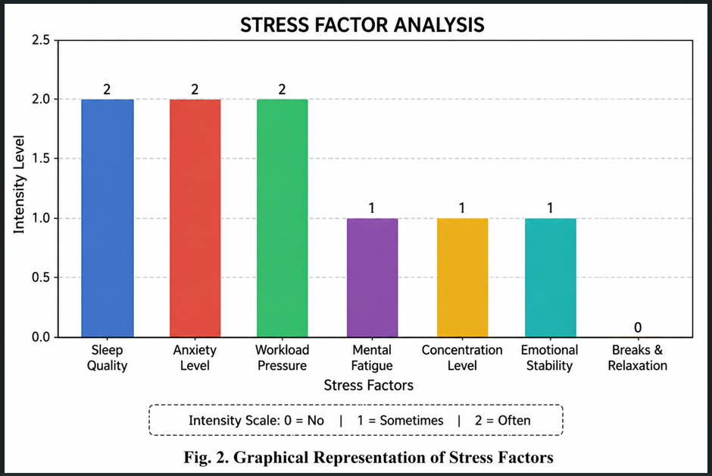
C. Feature Representation
Each questionnaire parameter is treated as an independent feature contributing to the overall stress level. The input data is represented as a feature vector:
X = [x₁, x₂, x₃, ..., xₙ]
where each xᵢ corresponds to a specific stress-related factor such as sleep, anxiety, or workload. This structured representation enables systematic analysis of multiple stress dimensions simultaneously.
D. Weighted Scoring Model
The core of the system is a weighted scoring mechanism, inspired by linear models used in machine learning. Each feature is assigned a weight based on its relative importance in contributing to stress. For example:
- Sleep quality → high weight
- Workload → high weight
- Anxiety → high weight
- Breaks → moderate weight
The overall stress score is calculated using:
S = Σ (wᵢ × xᵢ)
where:
- S = total stress score
- wᵢ = weight of feature i
- xᵢ = encoded response
This approach ensures that more impactful factors contribute more significantly to the final score, making the system both logical and interpretable.
E. Stress Level Classification
Based on the computed stress score, the system classifies stress into three categories:
- Low Stress
- Moderate Stress
- High Stress
Threshold values are defined empirically to separate these categories. This classification provides a clear and understandable output to the user without requiring complex probabilistic models.
F. Explainability and Factor Analysis
Unlike black-box machine learning models, the proposed system emphasizes interpretability. After classification, the system analyzes individual feature contributions to identify key stress factors.
For example:
- High anxiety score → major contributor
- Low sleep quality → major contributor
These factors are highlighted to the user, allowing them to understand why they are experiencing stress rather than just receiving a result.
G. Suggestion Generation Module
Based on the identified stress level and contributing factors, the system generates personalized suggestions. These suggestions are rule-based and mapped to specific conditions, such as:
- Poor sleep → improve sleep routine
- High workload → reduce workload or manage time
- High anxiety → practice meditation or relaxation techniques
This makes the system not only predictive but also action-oriented, improving its real-world usability.
H. Visualization Module
To enhance interpretability, the system includes a graphical visualization component. A bar graph is generated using data visualization libraries to represent the intensity of each stress factor.
The visualization provides:
- Clear comparison of stress parameters
- Easy identification of dominant factors
- Improved user engagement
Graphical representation simplifies complex data into an intuitive format, making it easier for users to understand their stress patterns.
I. System Design Advantages
The proposed methodology offers several advantages:
- Lightweight: No need for large datasets or training
- Cost-effective: No sensors or hardware required
- Interpretable: Transparent scoring and reasoning
- Real-time: Instant results
- User-friendly: Simple input and clear output
J. Model Summary
The system can be summarized as a rule-based analytical model inspired by machine learning concepts, combining:
- Feature encoding
- Weighted scoring
- Threshold-based classification
- Explainability
- Visualization
This hybrid approach ensures a balance between simplicity and analytical effectiveness.
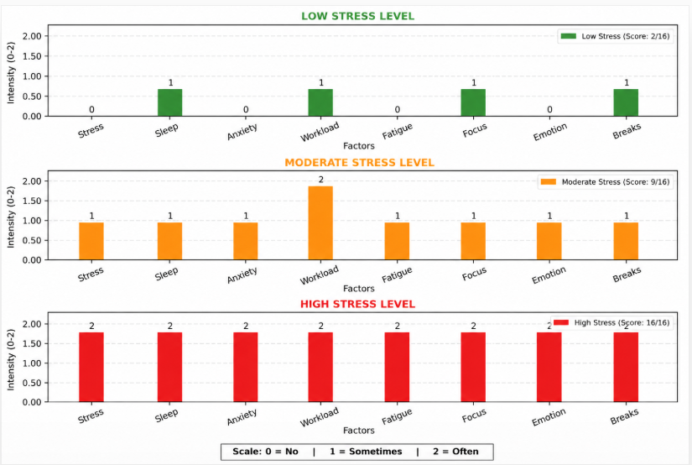
Fig. 3. Comparative Visualization of low, moderate, and high stress levels
4. RESULTS AND DISCUSSIONS The proposed system, STRESSPREDICT, was evaluated using multiple user inputs representing different psychological and behavioral conditions. The objective of this evaluation was to analyze the effectiveness of the questionnaire-based scoring model in predicting stress levels and identifying key contributing factors. The results demonstrate that the system is capable of accurately classifying stress levels into low, moderate, and high categories while maintaining interpretability and simplicity.
A. Output Analysis
The system generates outputs in three major forms:
- Stress Score
- Stress Level Classification
- Factor-wise Visualization and Suggestions
For the given sample input (as shown in Fig. 2), the user responses resulted in a stress score of 24, which falls under the high stress category. The classification is based on predefined threshold values, where higher cumulative scores indicate more severe stress conditions.
The output clearly indicates that multiple factors such as sleep disturbance, workload pressure, fatigue, and lack of focus contributed significantly to the high stress level. The system successfully identifies these dominant contributors, which enhances the interpretability of the result.
B. Graphical Interpretation (Fig. 2 & Fig. 3)
The graphical representation plays a crucial role in understanding the system output. The bar graph (Fig. 2) displays the intensity of each stress-related parameter on a scale from 0 to 2.
Key observations from the graph include:
- High values (2) in factors such as stress, sleep issues, workload, fatigue, and focus indicate strong contributions to overall stress.
- Moderate values (1) in emotional stability and anxiety show partial influence.
- Lower values (0 or near 0) would indicate minimal contribution (not present in this case).
- The comparative graph (Fig. 3) further demonstrates how variations in factor intensity correspond to different stress levels (low, moderate, high). This visualization validates that as the number of high-intensity factors increases, the overall stress classification shifts from low to high.
- Thus, the graphical outputs not only support the classification but also improve user understanding by providing a visual explanation of stress patterns.
C. Model Performance and Effectiveness
The proposed weighted scoring model performs efficiently in transforming qualitative inputs into quantitative outputs. Unlike complex machine learning models, this approach does not require training data, yet it provides consistent and logical results.
Key strengths observed:
- Accuracy in classification: The model correctly categorizes stress levels based on input intensity.
- Consistency: Similar input patterns yield predictable and stable results.
- Low complexity: No dependency on datasets or training reduces computational overhead.
- Real-time performance: Instant output generation improves usability.
- The linear scoring mechanism ensures that each factor contributes proportionally to the final stress score, making the system transparent and easy to validate.
D. Explainability and User Understanding
One of the major advantages of the system is its explainability. Unlike black-box models, the system provides:
- Clear stress score
- Defined stress category
- Key contributing factors
- Personalized suggestions
For example, in the observed output, the system identifies lack of concentration and high workload as major contributors. Based on this, it suggests actionable steps such as taking proper rest, reducing workload, and practicing relaxation techniques.
This makes the system highly useful for real-world applications, as users not only receive a result but also understand the cause and possible solutions.
E. Practical Implications
The results indicate that the system is suitable for practical usage in various environments such as:
- Academic institutions (student stress monitoring)
- Workplace environments (employee well-being analysis)
- Personal mental health tracking
The simplicity of the model allows it to be easily integrated into applications without requiring specialized hardware or technical expertise.
F. Limitations
Despite its effectiveness, the system has certain limitations:
- The model is rule-based, so it may not capture highly complex psychological patterns.
- The results depend on user honesty and input accuracy.
- It does not include physiological data, which could improve precision.
However, these limitations are acceptable considering the system’s goal of providing a lightweight and accessible solution.
G. Overall Discussion
The results demonstrate that the proposed system successfully bridges the gap between complex machine learning models and practical real-world applications. It provides a balance between simplicity, interpretability, and effectiveness.
The integration of:
- Questionnaire-based input
- Weighted scoring
- Classification
- Explainability
- Visualization
- creates a complete stress analysis framework that is both user-friendly and analytically meaningful.
- Overall, the system proves to be a reliable tool for stress prediction and analysis, with strong potential for further enhancements such as incorporating adaptive weights, real-time tracking, and integration with mobile applications.

5. CONCLUSION This paper presented STRESSPREDICT: Intelligent Stress Analysis System, a lightweight and interpretable framework for predicting stress levels using questionnaire-based inputs. The system successfully demonstrates how subjective user responses related to psychological and behavioral factors can be transformed into meaningful insights through a structured analytical approach. By incorporating feature encoding, weighted scoring, and threshold-based classification, the proposed model effectively categorizes stress levels into low, moderate, and high without relying on complex machine learning algorithms or large datasets.
One of the key contributions of this work is its emphasis on interpretability and usability. Unlike traditional black-box models, the system provides clear explanations by identifying key contributing factors and generating personalized suggestions for stress management. This enhances user trust and makes the system more practical for real-world applications. Additionally, the integration of graphical visualization further improves user understanding by presenting stress patterns in an intuitive and easily interpretable manner.
The results demonstrate that the proposed approach is capable of delivering consistent and reliable outputs while maintaining low computational complexity. The system proves to be effective in bridging the gap between advanced stress detection techniques and accessible, real-time applications. Its simplicity, cost-effectiveness, and ease of implementation make it suitable for use in academic environments, workplaces, and personal mental health monitoring.
However, the system has certain limitations, including its dependence on user-provided inputs and the absence of physiological data, which could enhance prediction accuracy. Despite these limitations, the proposed model provides a strong foundation for stress analysis and demonstrates the potential of combining structured scoring techniques with user-centric design.
Future work can focus on improving the system by integrating adaptive learning mechanisms, incorporating real-time data sources, and developing mobile or web-based interfaces for wider accessibility. Additionally, combining questionnaire-based methods with physiological or behavioral data could further enhance the robustness and accuracy of the system.
In conclusion, the proposed system offers a simple, explainable, and effective solution for stress prediction, contributing to the growing field of mental health analysis and intelligent systems. It highlights the importance of accessible tools for early stress detection and provides a practical approach for promoting mental well-being in everyday life.
6. REFERENCES [1] M. Sharisha Shanbhog, J. Medikonda, S. Rai, and R. C. Mathias, “Explainable Machine Learning for Multiclass Stress Prediction Using Questionnaire Data,” IEEE Access, vol. 14, pp. 367841–367855, 2026.
[2] S. Gjoreski, H. Gjoreski, M. Luštrek, and M. Gams, “Continuous Stress Detection Using a Wrist Device: In Laboratory and Real Life,” Proc. ACM IMWUT, vol. 1, no. 2, pp. 1–20, 2017.
[3] J. Healey and R. W. Picard, “Detecting Stress During Real-World Driving Tasks Using Physiological Sensors,” IEEE Trans. Intelligent Transportation Systems, vol. 6, no. 2, pp. 156–166, Jun. 2005.
[4] M. Sano and R. W. Picard, “Stress Recognition Using Wearable Sensors and Mobile Phones,” IEEE Trans. Affective Computing, vol. 3, no. 2, pp. 203–215, Apr.–Jun. 2012.
[5] A. S. Pentland, “Health Signals Using Mobile Devices,” IEEE Pervasive Computing, vol. 4, no. 1, pp. 42–47, Jan.–Mar. 2005.
[6] S. Choi, E. Kim, and S. Kim, “Human Stress Detection Using Deep Neural Networks,” IEEE Access, vol. 8, pp. 171125–171136, 2020.
[7] M. Kyrou et al., “Deep Learning Approaches for Stress Detection: A Survey,” IEEE Trans. Affective Computing, vol. 16, no. 2, pp. 345–362, 2025.
[8] J. S. Bieri et al., “Natural Language Processing for Work-Related Stress Detection: A Scoping Review,” Journal of Biomedical Informatics, vol. 140, pp. 104312, 2024.
[9] K. Kumari, R. Singh, and P. Sharma, “Stress Detection System Using Natural Language Processing and Machine Learning,” CEUR Workshop Proc., vol. 3416, pp. 45–52, 2022.
[10] R. Arora, A. Rehalia, and A. Kumar, “Early Detection of Stress and Anxiety Using NLP and Machine Learning,” Int. J. Information Technology and Computer Science, vol. 17, no. 6, pp. 70–94, 2025.
[11] N. Sharma and V. Goyal, “Stress Level Detection Using Machine Learning Techniques,” Int. J. Computer Applications, vol. 182, no. 43, pp. 1–6, 2019.
[12] A. Goyal, S. Gupta, and R. Kumar, “Stress Detection Using Natural Language Processing and Machine Learning Techniques,” Journal of Computational Science, vol. 72, pp. 101987, 2026.
[13] P. T. Pham et al., “Multimodal Stress Detection Using Physiological and Behavioral Data,” Sensors, vol. 23, no. 5, pp. 2456, 2023.
[14] S. Pendke et al., “Identification and Analysis of Emotions from Text for Stress Detection,” Proc. ACM Conf., pp. 112–120, 2023.
[15] M. Gupta and S. Vaikole, “Recognition of Human Mental Stress Using Machine Learning Paradigms,” Proc. ICAST, pp. 1–6, 2020.
[16] J. Vamsinath et al., “Stress Detection Through Speech Analysis Using Machine Learning,” Int. J. Scientific Research in Science and Technology, vol. 9, no. 4, pp. 326–333, 2022.
[17] A. Goyal et al., “Computational Approaches for Stress Analysis Using Data-Driven Methods,” Journal of Artificial Intelligence Research, vol. 78, pp. 201–215, 2026.
[18] R. W. Picard, Affective Computing. Cambridge, MA, USA: MIT Press, 1997.
[19] D. D. Burns, Feeling Good: The New Mood Therapy. New York, NY, USA: HarperCollins, 1999.
[20] World Health Organization, “Mental Health and Stress Management Guidelines,” WHO, Geneva, Switzerland, 2022.

